Activity Sheet Answers
Chapter 5, Lesson 2
Surface Tension

EXPLAIN IT WITH ATOMS & MOLECULES

- You saw a demonstration of a paper clip floating at the surface of water. Paper clips are more dense than water and usually sink. Why do you think the paperclip was able to stay on the surface of the water?
The paper clip was able to stay on the surface of the water because of water’s high surface tension.

ACTIVITY

- What did the water look like as you added it to the top of the test tube and the penny?
Water formed a dome or a “hill” above the surface of the penny and the test tube.

- Use the illustration to explain why water has a strong surface tension.
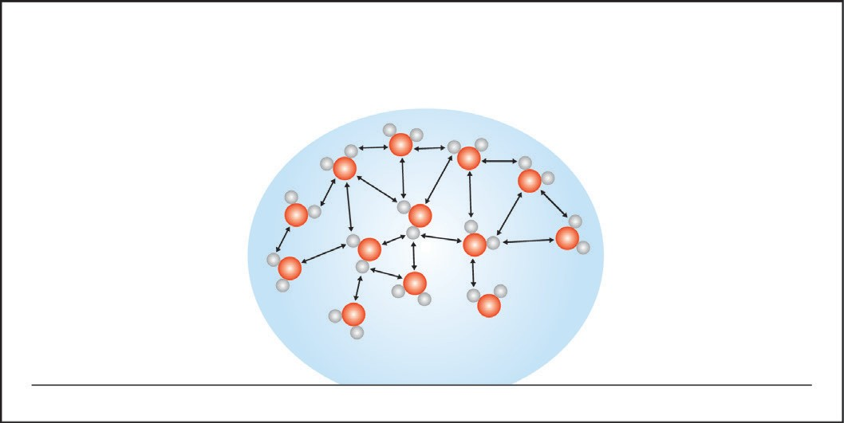
Water has a high surface tension because the water molecules at the surface only feel an attraction for the other molecules that are next to them and beneath them. The surface molecules are pulled together and inward by these attractions.

ACTIVITY

- How many drops of each liquid were you able to get on a penny?
Answers will vary, but more drops of water than alcohol should be able to be added to the penny without overflowing.

- Does alcohol or water have a greater surface tension? How do you know?
Water has a greater surface tension than alcohol because it is able to attract other water molecules more strongly than alcohol molecules can attract each other. This was demonstrated in the activity when more water was able to be added to the penny because water has a greater attraction for itself, or greater surface tension.

- How does the polarity of alcohol and water molecules affect the surface tension of each liquid?
Because water molecules are more polar and smaller than alcohol molecules, they are held more tightly and closer together than alcohol molecules giving water the stronger surface tension.

ACTIVITY

- What happens when you add a small amount of detergent to a large drop of water?
When you add detergent to a large drop of water, the water spreads out. It does this because the detergent interferes with the attractions that water molecules have for one another and therefore decreases its surface tension.

- Use the illustration to explain how detergent interferes with water’s surface tension.
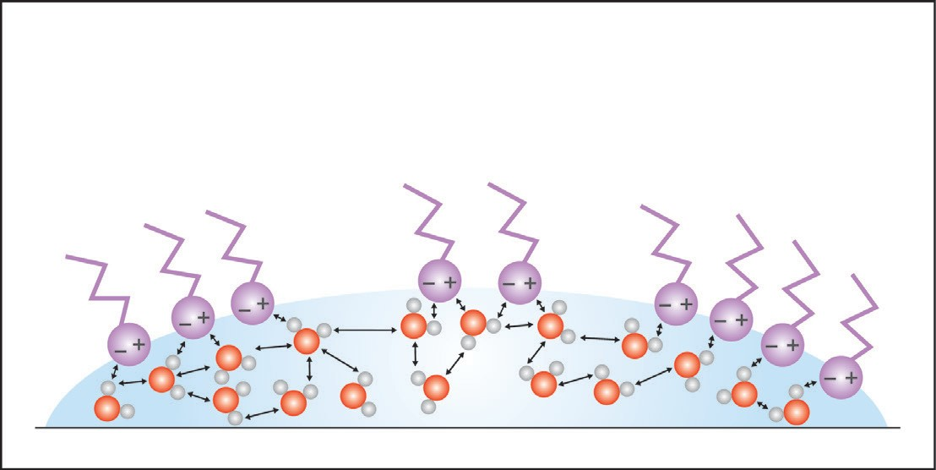
Detergent interferes with water’s surface tension by competing for water’s attraction with itself. Rather than water molecules at the surface being attracted to only those water molecules adjacent or below them, water molecules at the surface become attracted to the detergent molecules, and the water molecules no longer experience the inward pull of surface tension.

TAKE IT FURTHER
- If water absorbs into a paper towel but does not absorb into wax paper, what does that say about the polarity of paper and the polarity of wax paper?
Water soaks into a paper towel because the molecules that compose a paper towel are also polar molecules. Water beads up on wax paper because the wax molecules are non-polar.

